WonderMaize User Guide

**Objective**

The objective of the WonderMaize game is to navigate through the randomly generated maze to find 5 different mysterious objects hidden.

**Basic Controls**

|  |  |
| --- | --- |
| Key | Action |
| W | Move forward |
| A | Turn left |
| S | Move backwards |
| D | Turn right |
| Esc | Quit the game |

**Gameplay**

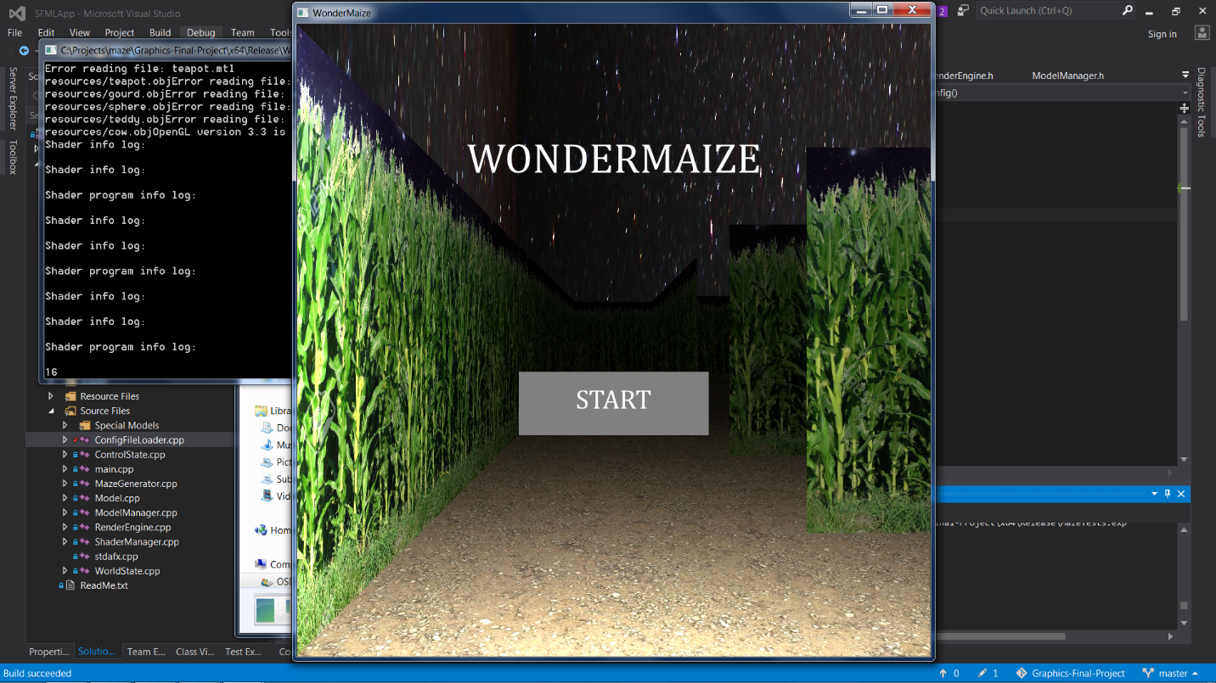

Upon opening the game, a box will pop up to begin playing the game. Click in the box to begin playing the game.

Once in the maze, the goal is to find all 5 hidden objects. The objects that are hidden in the maze are a Cow, Gourd, Sphere, Teapot, and Teddy Bear. Initially all objects are colored red. To actually find the object, simply run close to it and a swirly effect will appear on the screen and the object will change color to yellow.

|  |  |  |  |  |
| --- | --- | --- | --- | --- |
|  |  |  |  |  |
| Sphere | Teapot | Gourd | Teddy Bear | COW?? |

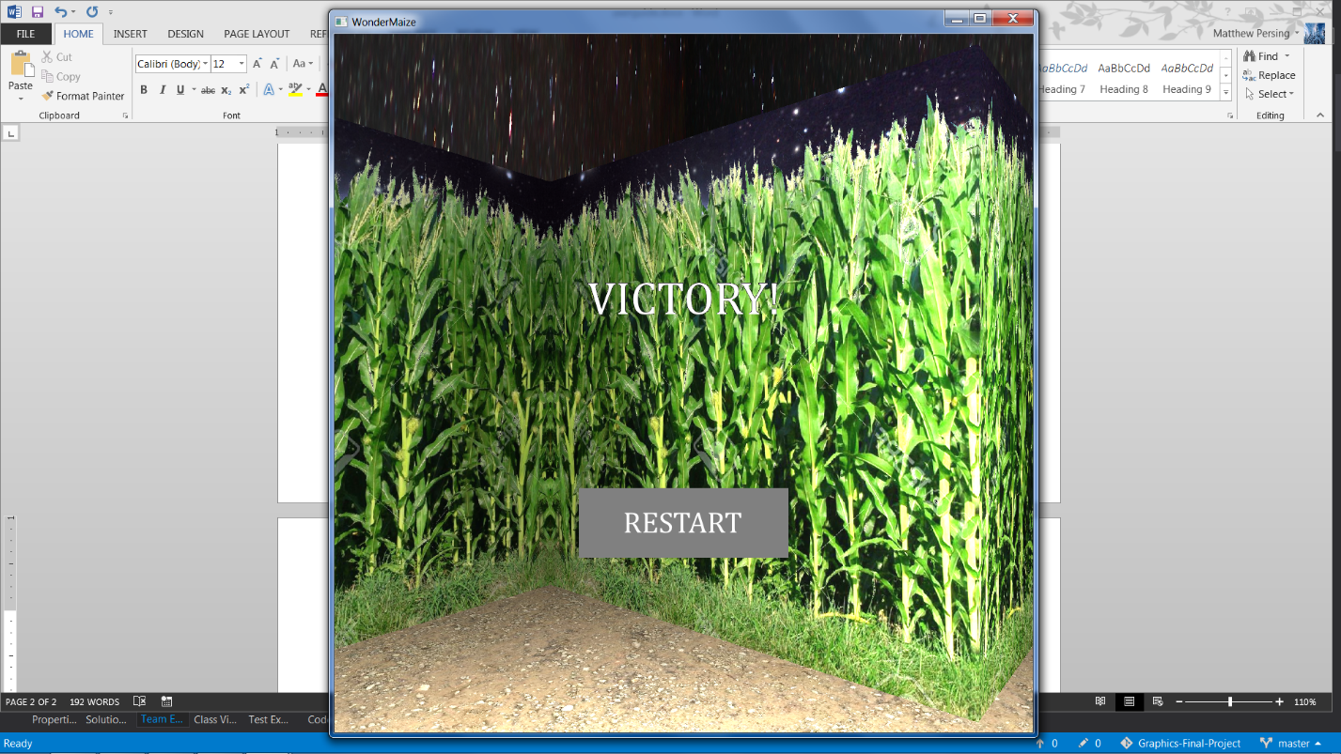After finding all of the models, a screen showing that the player has won will appear. To restart the game, press the “Restart” button in the middle of the screen. After pressing the “Restart” button, a new maze will be randomly generated and the objects to find will be randomly scattered throughout the maze.